EXPERIMENT-10
10) Perform a 90-degree rotation clockwise along the y-axis for the given image.
a) CODE
from PIL import Image
img = Image.open("photo.jpg")
rotate = img.rotate(-90, expand=True)
rotate.save("rotated.jpg")
print("Image rotated successfully")

b) INPUT
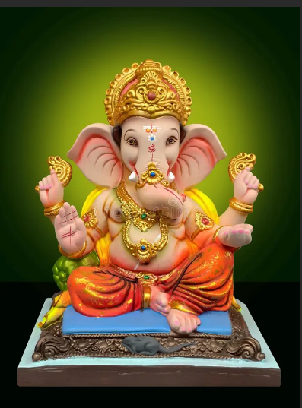
c) OUTPUT
